

**Project report**

Project Title: **Constructing a simple DC Circuit**

**for Traffic Signal system**

Course Code: **CSE109**

Course Title : **Electrical Circuits**

Section : **1**

**Submitted to**

**Dr. Waselul Haque Sadid**

Assistant Professor of CSE

East West University

**Submitted by**

**Robayed Ashraf**

ID: **2018-1-60-238**

Department of CSE

East West University

**Submission date: 11 November, 2018**

# Project Introduction:

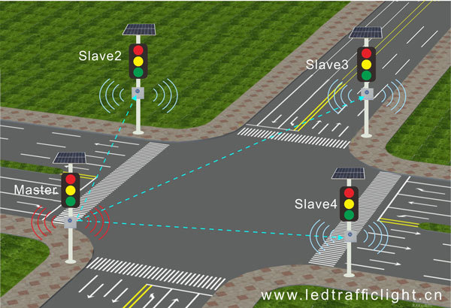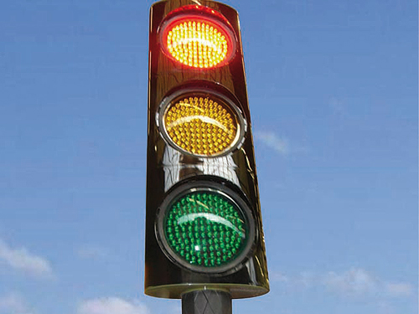

Figure 01: Traffic signal system

At a cross section of four way roads there are a set of lights (Red, Yellow and Green) for signals to control the traffic. Each road will be open for some time when only the green light is on. When the red light is on no vehicle is allowed to run on that road. The yellow light will be turned on for few seconds between the change of red to green or green to red in any set.

**Equipment List:**

1. 9V DC voltage source (1 pc)
2. Switch (3 pcs)
3. 270 Ω Resister (3pcs)
4. LED (Red = 4 pcs; Green = 4 pcs ; Yellow = 4pcs)
5. Connecting wires (jumper wires)
6. Breadboard

**Circuit Diagram:**

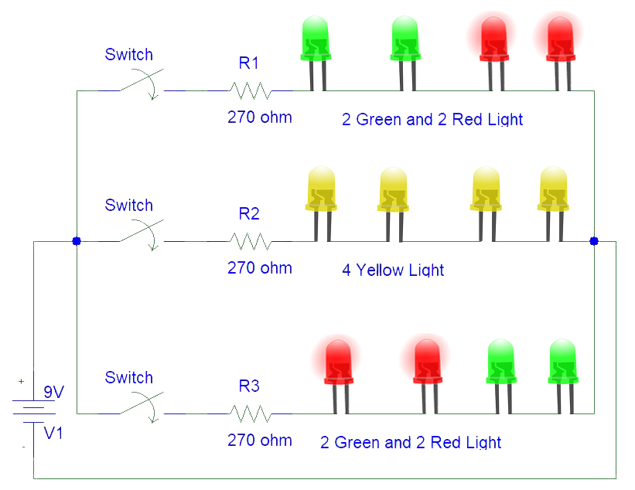

Figure 2: Circuit diagram of a manual controlled traffic signal.

**Circuit picture:**

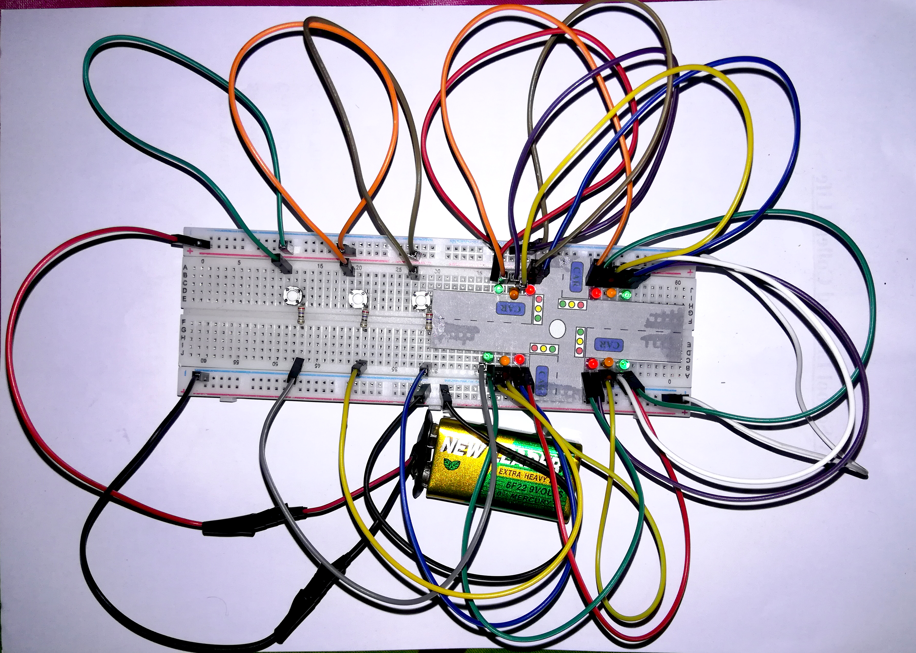

Figure 3: Circuit to maintain the traffic signal.

**Circuit Description:**

The traffic signal system is made with the help of 3 push switches. These are mainly used to turn off or on the LED lights. We have also used 270 Ω resistor and 9V DC for power supply. There are 2 red light and 2 green lights in series connection. This set is parallel with another 2 set. They are the set of series connection of 2 red and 2 green lights and the set of series connection of 4 yellow light**s**.

**Discussion:**

By this project a four way road traffic system can be maintain easily. It can be reduce the traffic jam of a busy city. It helps to move the passenger to their destination in a short time. It also reduces the tiredness of journey. Thus the project can make our life easier and more comfortable.